- Sum of n numbers in an array using pointers.
#include <stdio.h>
int main()
{
int arr[5] = {1,2,3,4,5};
int *ptr = arr;
int sum = 0;
for (int i = 0; i < 5; i++) {
sum += *(ptr + i);
}
printf("Sum of array elements:%d\n",sum);
return 0;
}
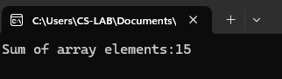
- Finding the largest element in an array using pointers and double pointers. largest element in an array using pointers
#include <stdio.h>
int main()
{
int arr[100],n;
int *ptr,largest;
printf("Enter number of elements:");
scanf("%d",&n);
printf("Enter %d elements:\n", n);
for (int i=0;i<n;i++) {
scanf("%d", &arr[i]);
}
ptr = arr;
largest = *ptr;
for (int i = 1; i < n; i++) {
if (*(ptr + i) > largest) {
largest = *(ptr + i);
}
}
printf("The largest element in the array is: %d\n", largest);
return 0;
}
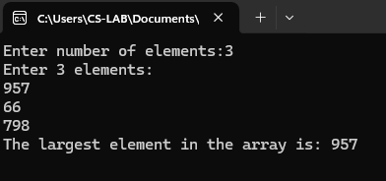
#include <stdio.h>
int main() {
int arr[100], n, i;
int *p;
int **dp;
int max;
printf("Enter number of elements: ");
scanf("%d", &n);
printf("Enter array elements:\n");
for (i = 0; i < n; i++)
scanf("%d", &arr[i]);
p = arr;
dp = &p;
max = **dp;
for (i = 1; i < n; i++) {
*p = arr[i];
if (**dp < arr[i])
max = arr[i];
}
printf("Largest element = %d\n", max);
return 0;
}
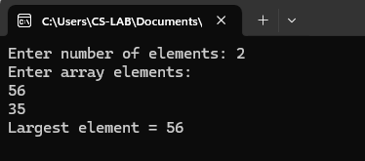
- C Program to swap values using pointers and Double Pointers C Program to swap values using pointers
#include <stdio.h>
int main() {
int a, b, temp;
int *p1, *p2;
printf("Enter two numbers: ");
scanf("%d %d", &a, &b);
p1 = &a;
p2 = &b;
temp = *p1;
*p1 = *p2;
*p2 = temp;
printf("After swapping:\n");
printf("a = %d\n", a);
printf("b = %d\n", b);
return 0;
}
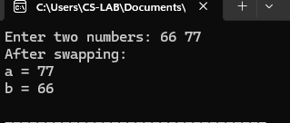
C Program to swap values using Double pointers
#include <stdio.h>
int main() {
int a, b, temp;
int *p1, *p2;
int **dp1, **dp2;
printf("Enter two numbers: ");
scanf("%d %d", &a, &b);
p1 = &a;
p2 = &b;
dp1 = &p1;
dp2 = &p2;
temp = **dp1;
**dp1 = **dp2;
**dp2 = temp;
printf("After swapping:\n");
printf("a = %d\n", a);
printf("b = %d\n", b);
return 0;
}
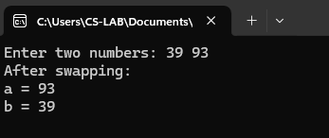
- Write a C program to dynamically allocate memory for storing the marks of N students. The program should read the marks from the user, display them, and calculate the average mark of the class
#include <stdio.h>
#include <stdlib.h>
int main() {
int N;
float *marks;
float sum = 0.0, average;
printf("Enter the number of students: ");
scanf("%d", &N);
if (marks == NULL) {
printf("Memory allocation failed!\n");
return 1;
}
for (int i = 0; i < N; i++) {
printf("Enter marks for student”);
scanf("%f", (marks + i));
sum += *(marks + i);
}
printf("\nMarks of all students:\n");
for (int i = 0; i < N; i++) {
printf("Student %.2f\n", marks + i);
}
average = sum / N;
printf("\nAverage marks = %.2f\n", average);
free(marks);
return 0;

- A company initially stores salaries of 4 employees. Later, 3 more employees join, and the program needs to adjust memory dynamically to store their salaries without losing the existing data. Task: ● Allocate memory for 4 employees’ salaries. ● Input and display those salaries. ● Expand memory dynamically to accommodate 3 more employees. ● Input and display salaries of all 7
#include <stdio.h>
#include <stdlib.h>
int main() {
int i;
float *salaries;
salaries = (float *)malloc(4 * sizeof(float));
if (salaries == NULL) {
printf("Memory allocation failed!\n");
return 1;
}
printf("Enter salaries of 4 employees:\n");
for (i = 0; i < 4; i++) {
printf("Employee %d: ", i + 1);
scanf("%f", (salaries + i));
}
printf("\nSalaries of 4 employees:\n");
for (i = 0; i < 4; i++) {
printf("Employee %d: %.2f\n", i + 1,*(salaries + i));}
salaries = (float *)realloc(salaries, 7 * sizeof(float));
if (salaries == NULL) {
printf("Memory reallocation failed!\n");
return 1;
}
printf("\nEnter salaries of 3 new employees:\n");
for (i = 4; i < 7; i++) {
printf("Employee %d: ", i + 1);
scanf("%f", (salaries + i));
}
printf("\nSalaries of all 7 employees:\n");
for (i = 0; i < 7; i++) {
printf("Employee %d: %.2f\n", i + 1,*(salaries + i));
}
free(salaries);
return 0;
}
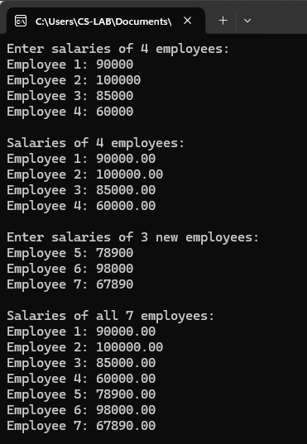
- A sports coach wants to record the scores of players in a tournament. Task: ● Ask the user to enter the number of players N. ● Dynamically allocate memory to store the scores of N players. ● Input the scores for all players. ● Display the scores of each player. ● Calculate and display the highest, lowest, and average score. ● Free the allocated memory after use.
#include <stdio.h>
#include <stdlib.h>
int main() {
int N, i;
int *scores;
int highest, lowest;
float sum = 0.0, average;
printf("Enter number of players: ");
scanf("%d", &N);
scores = (int *)malloc(N * sizeof(int));
if (scores == NULL) {
printf("Memory allocation failed!\n");
return 1;
}
for (i = 0; i < N; i++)
{
printf("Enter score for player %d: ", i + 1);
scanf("%d", (scores + i));
sum += *(scores + i);
}
highest = lowest = *(scores + 0);
for (i = 1; i < N; i++)
{
if (*(scores + i) > highest)
highest = *(scores + i);
if (*(scores + i) < lowest)
lowest = *(scores + i);
}
average = sum / N;
printf("\nScores of players:\n");
for (i = 0; i < N; i++) {
printf("Player %d: %d\n", i + 1,*(scores + i));
}
printf("\nHighest score: %d\n", highest);
printf("Lowest score: %d\n", lowest);
printf("Average score: %.2f\n", average);
free(scores);
return 0;
}
